

EBAY CONTROLLER TEST DATA SHEET

P/N: N/A Date: 08/03/2018 Time: 16:18

S/N: N/A Tested by: Joseph

Hardware Rev: BLDC_60A_V6 Approved by: Joseph

Software Rev: N/A

Equipments Used

Equipments Model No Serial No

Power Supply

Digital Multimeter

CAN Interface

Resistance Decade Box

PC

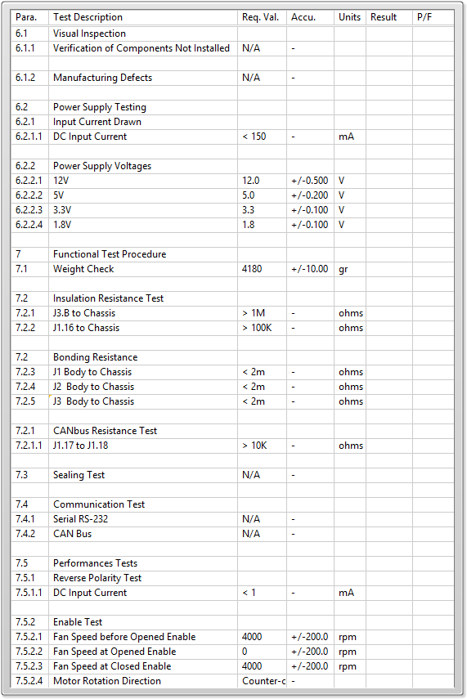

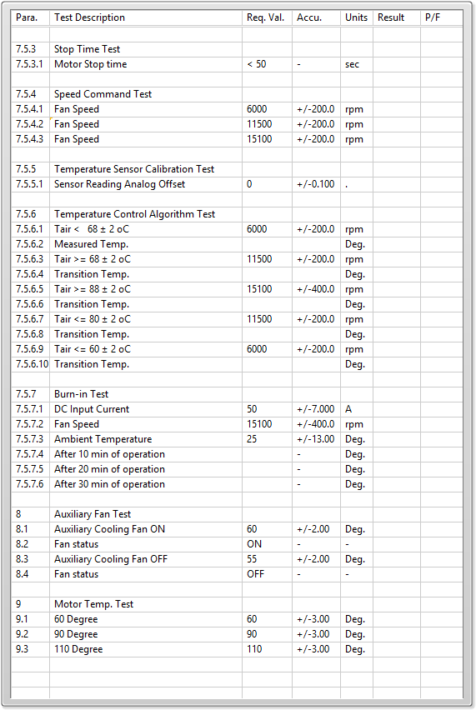

General result:

Test-Operator:____ Joseph_________ Q.A.:__________________________